**ELASTIC CONTAINER REGISTRY:**

**ECR DEFINATION:**

Amazon Elastic Container Registry (ECR) is a fully managed container registry that makes it easy to store, manage, share, and deploy your container images and artifacts anywhere.

**ECR PRICING:**

You pay only for the amount of data you store in your public or private repositories and data transferred to the Internet.

**BENEFITS:**

### Fully managed

Amazon ECR eliminates the need to operate and scale the infrastructure required to power your container registry.

### Secure

Amazon ECR transfers your container images over HTTPS and automatically encrypts your images at rest.

### Simplified workflow

Amazon Elastic Container Registry integrates with Amazon EKS, Amazon ECS, Amazon Lambda, and the Docker CLI, allowing you to simplify your development and production workflows.

### Highly available

Amazon ECR has a highly scalable, redundant, and durable architecture, so your container images are highly available and accessible.

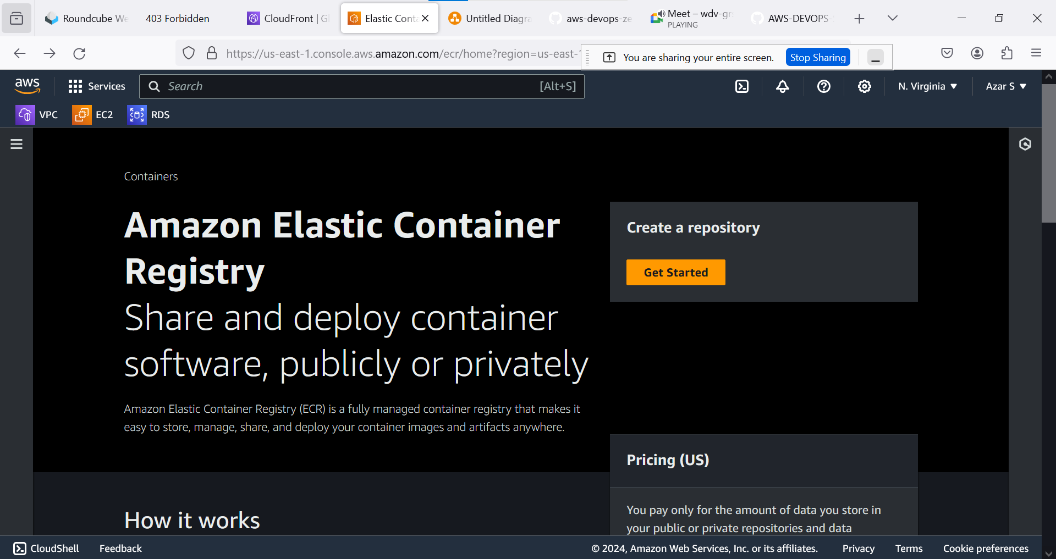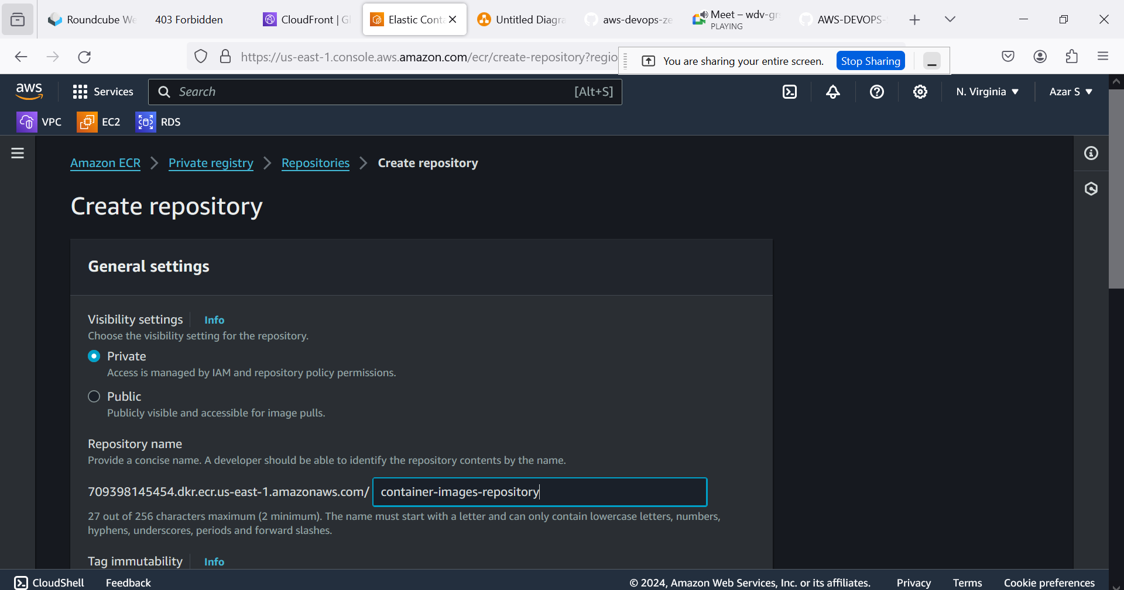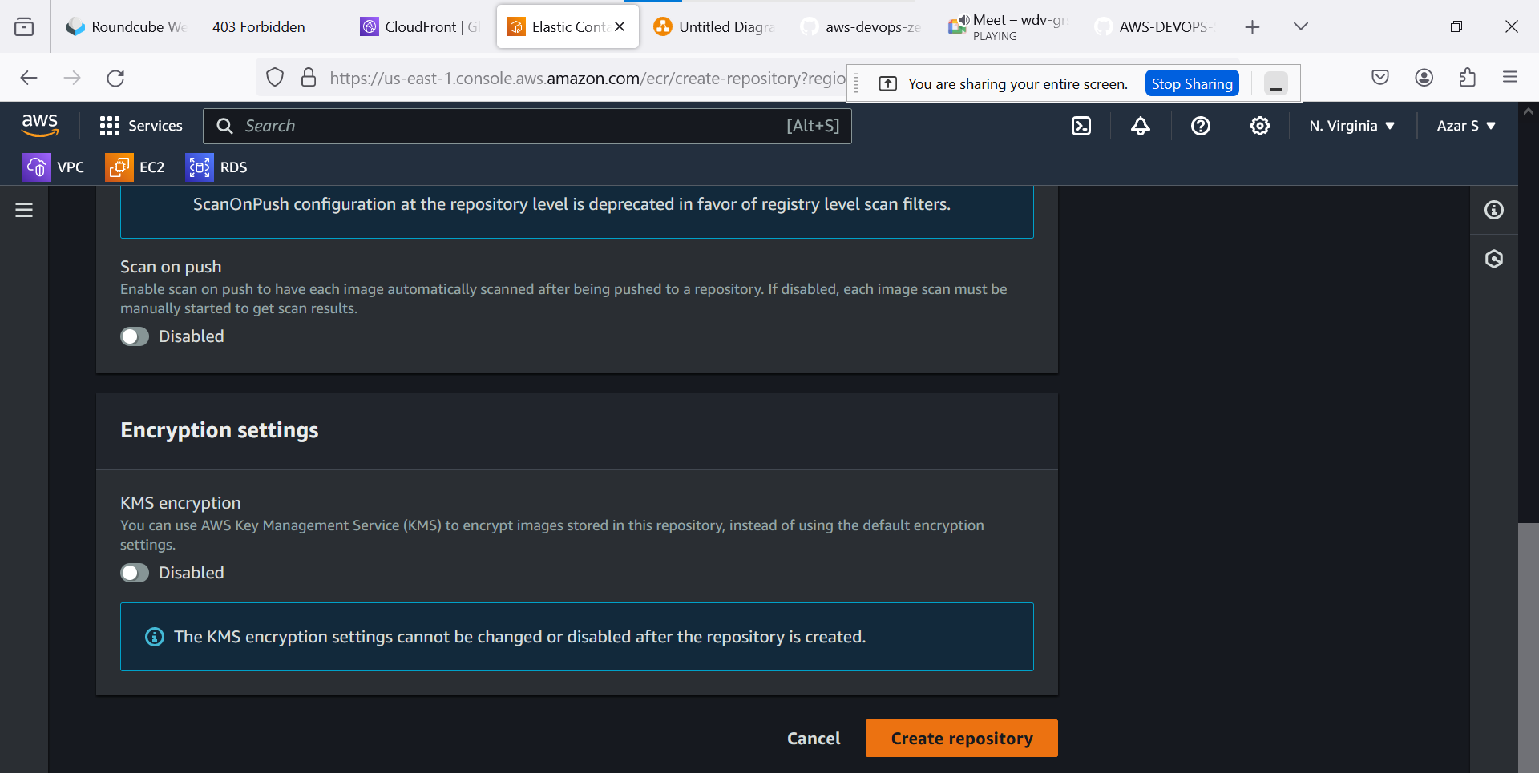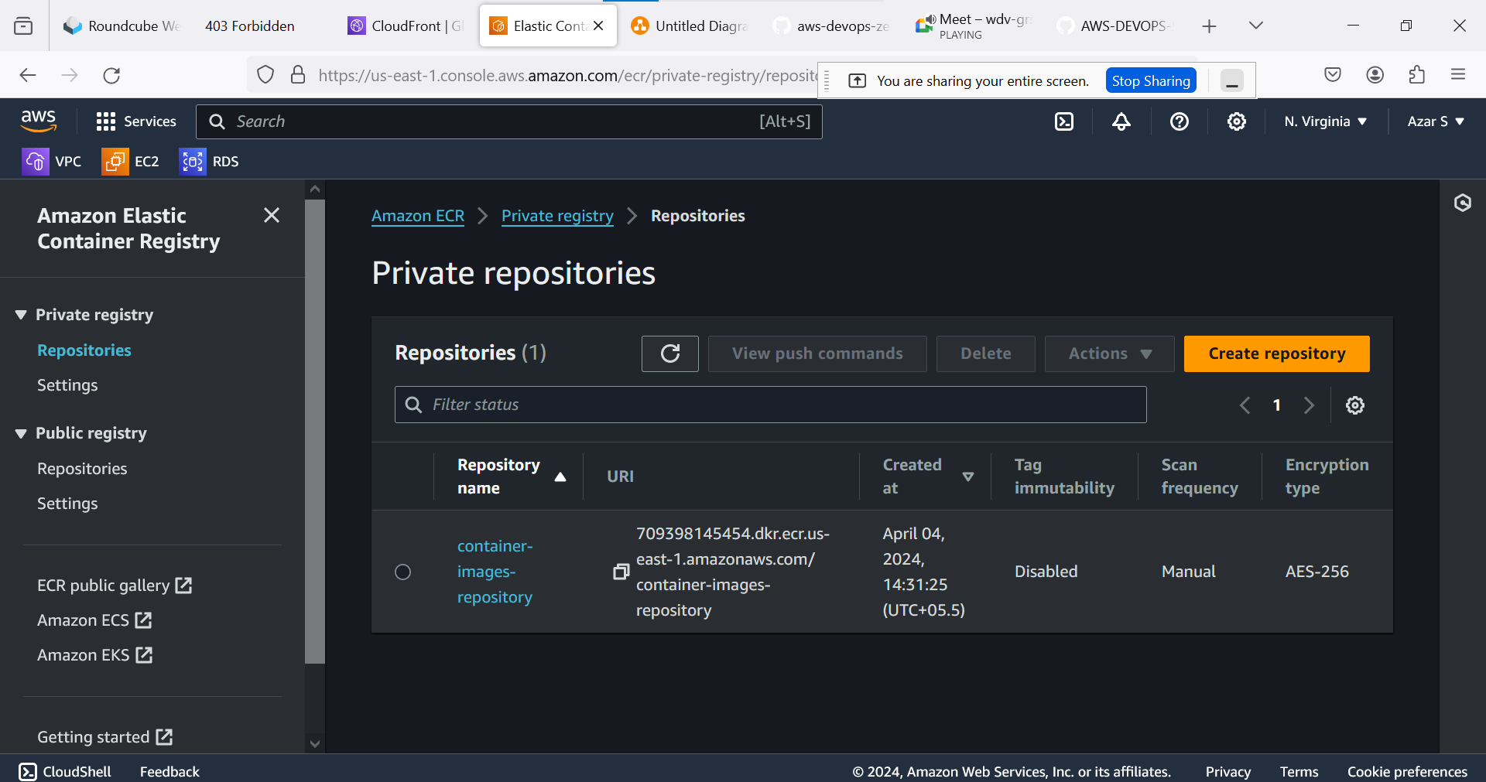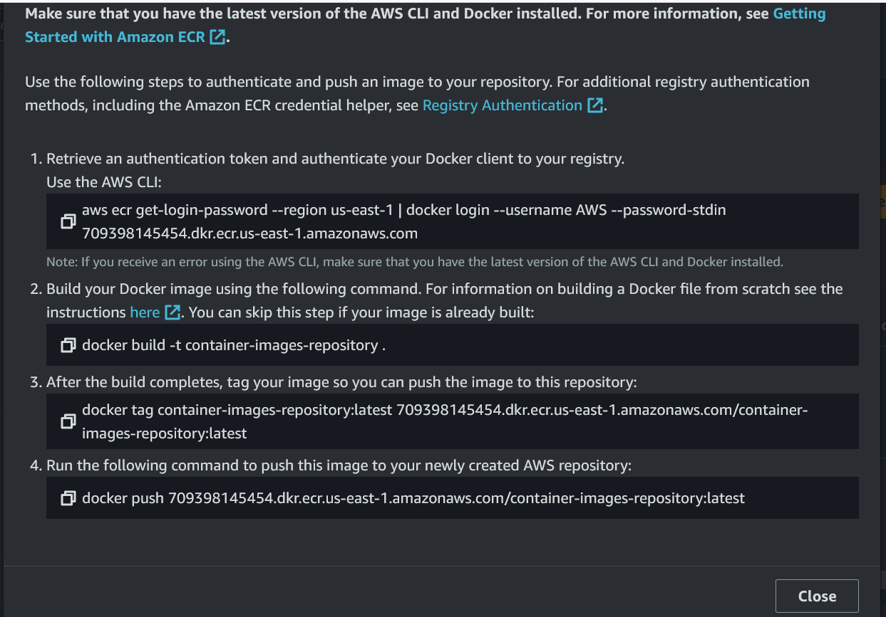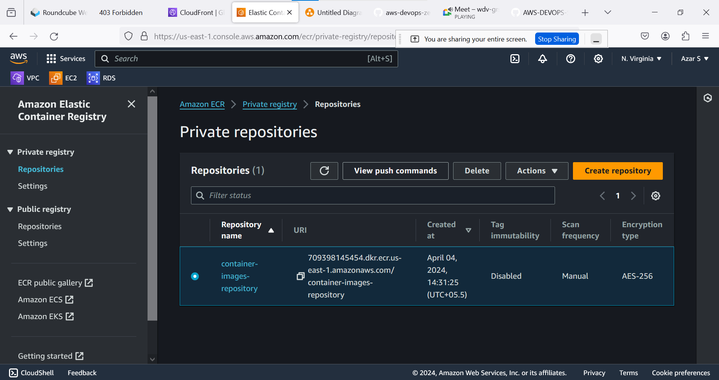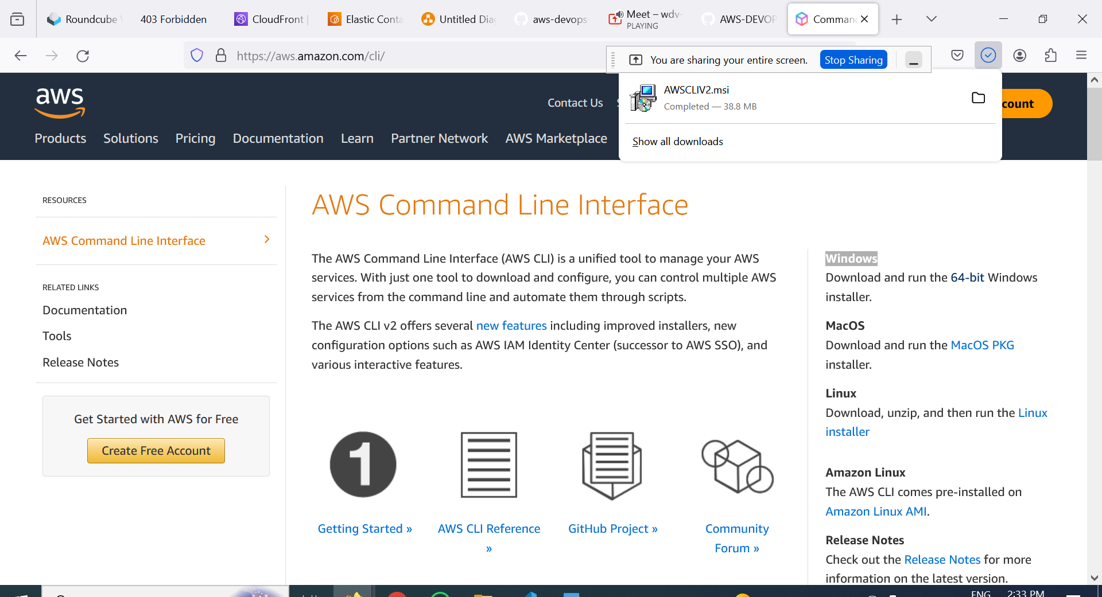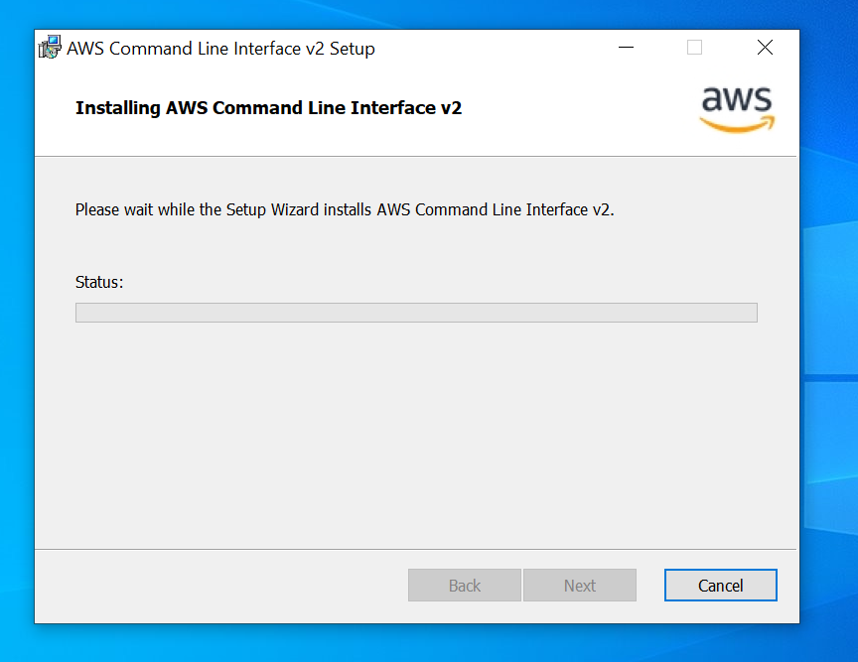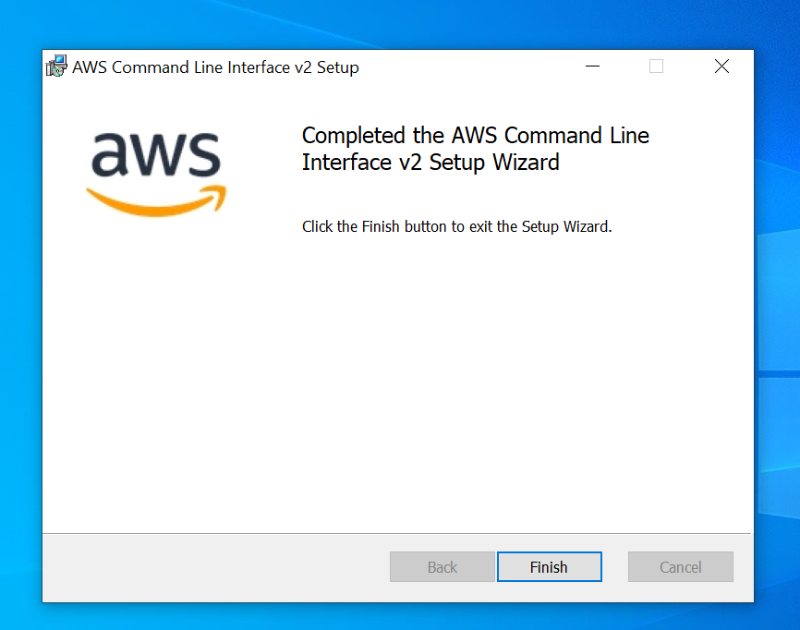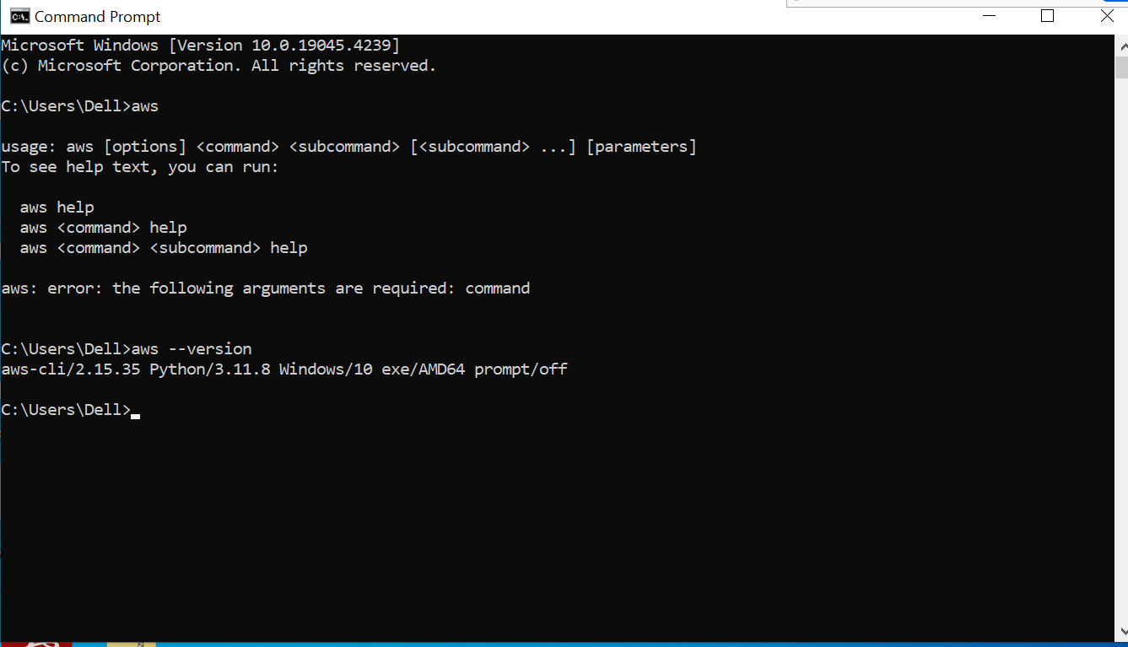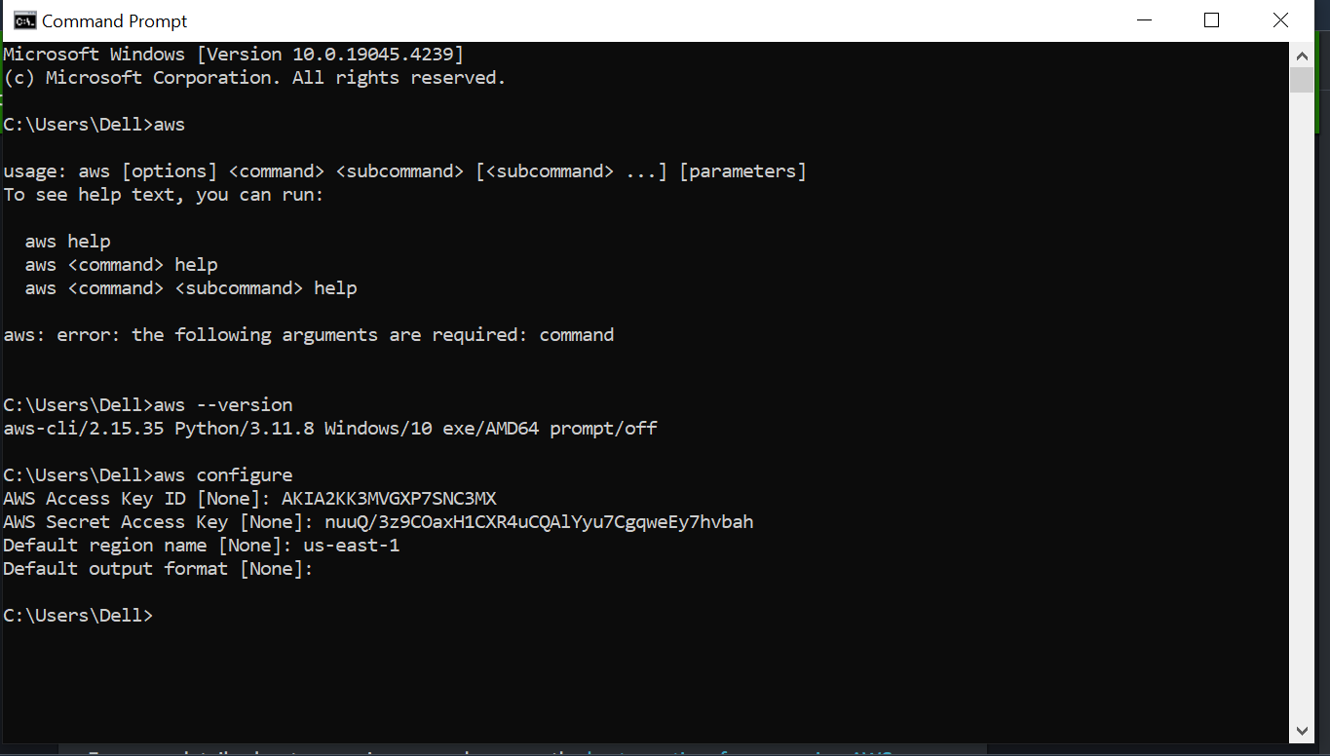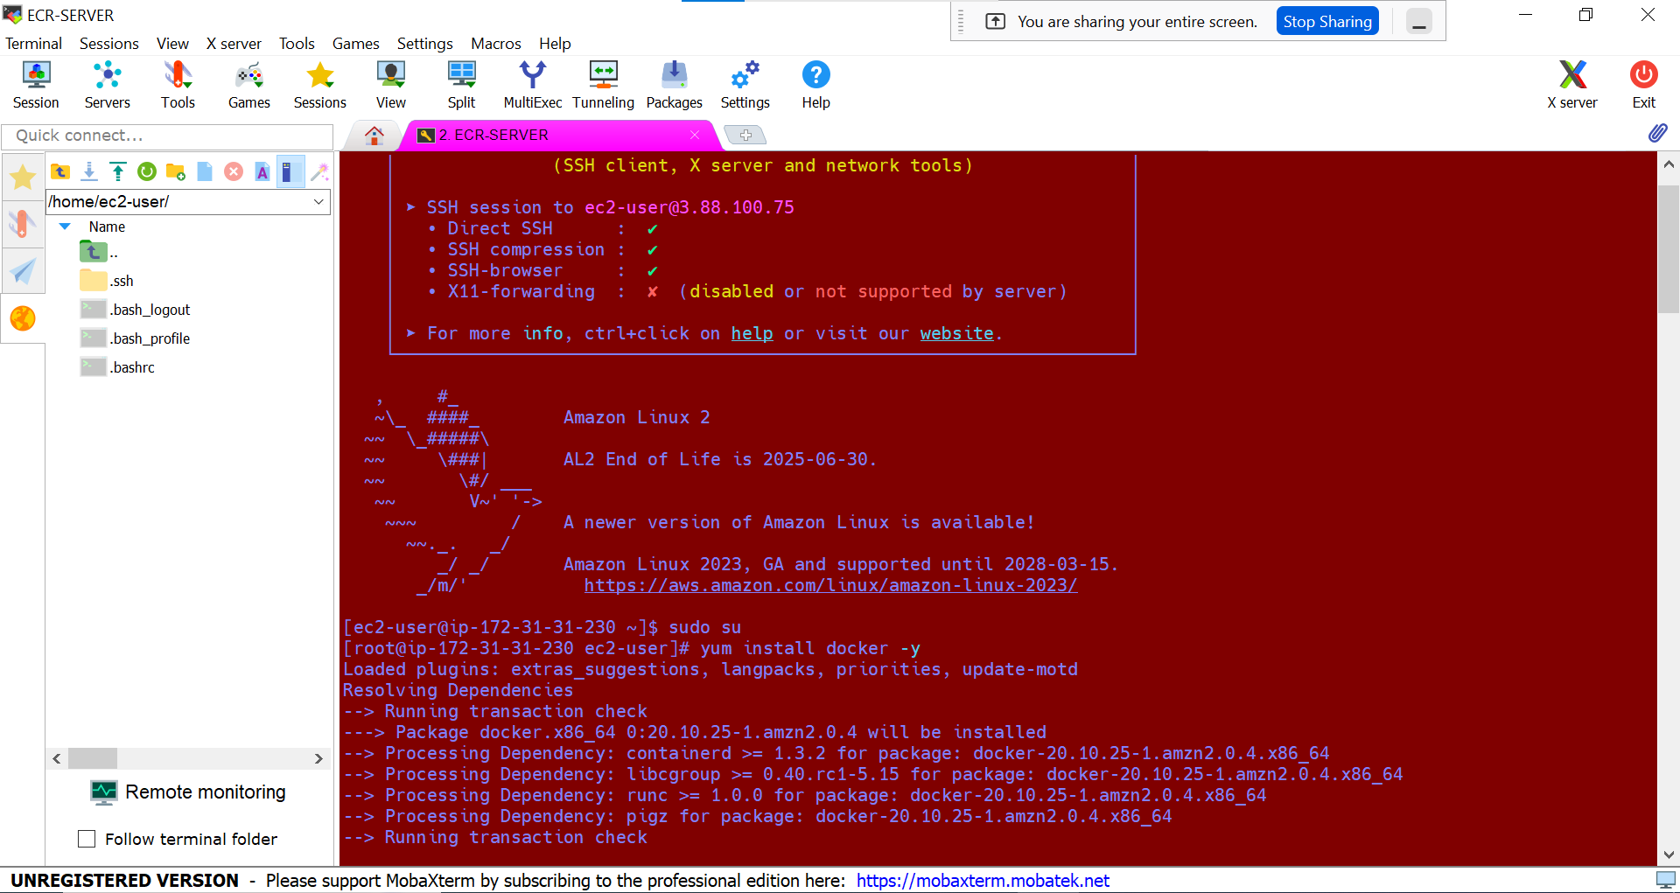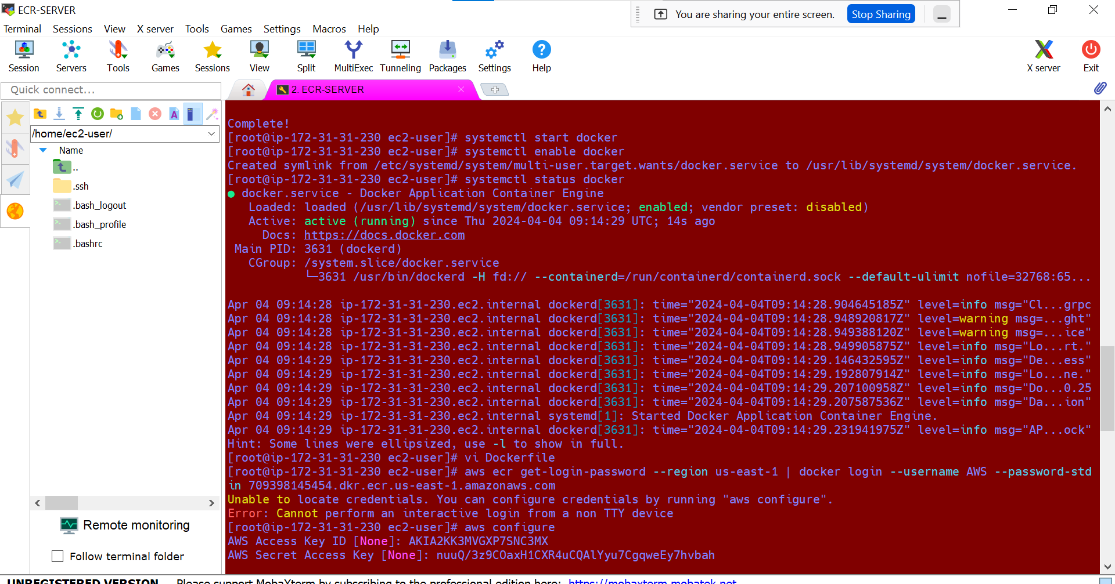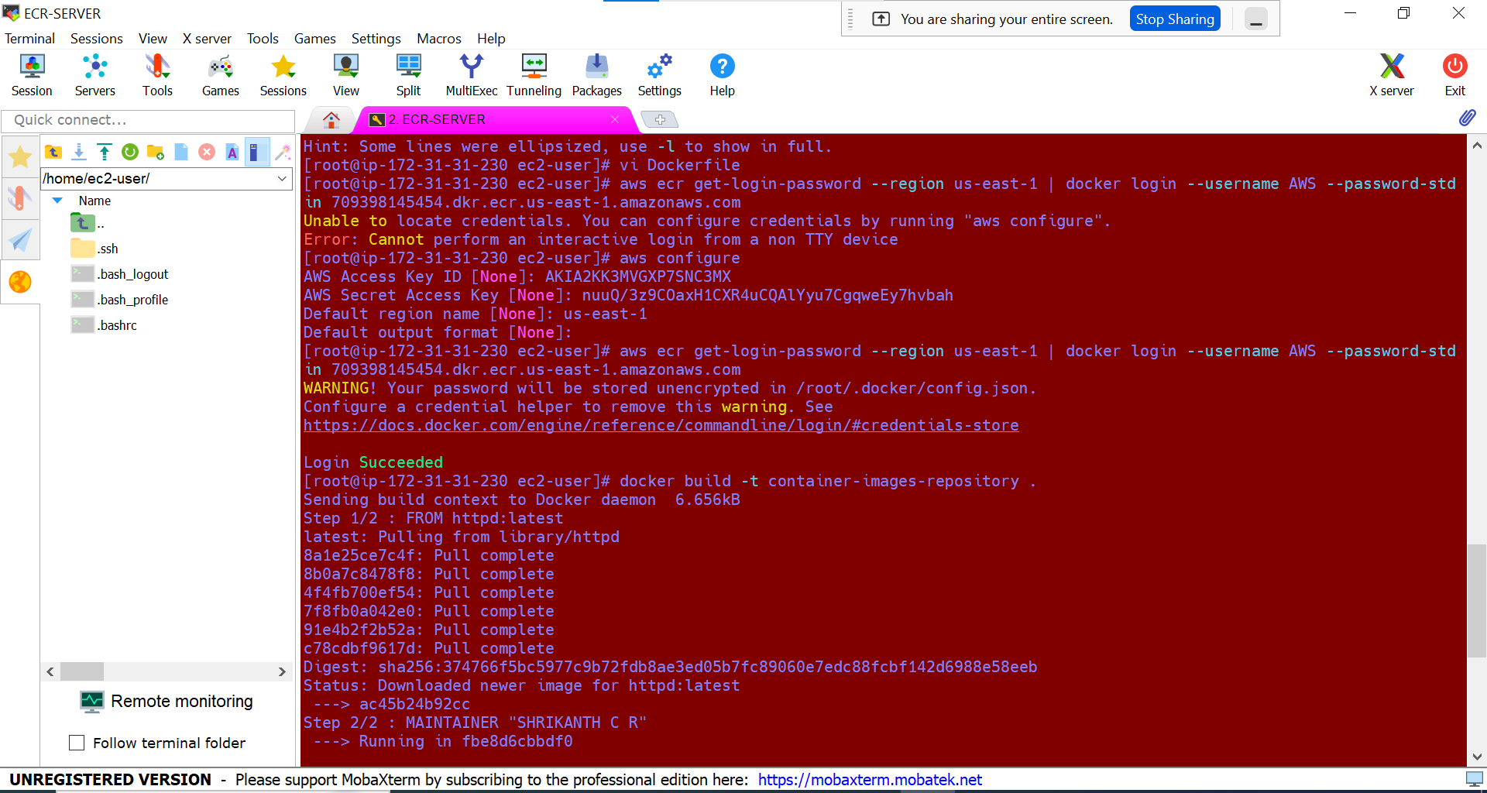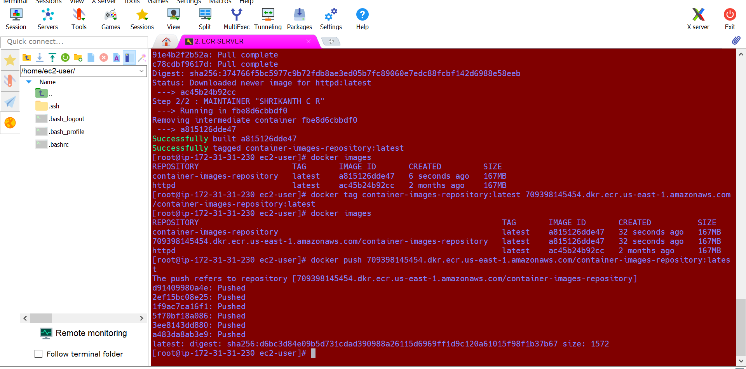

Click on view push